Exercise 1: Control Structures
- TABLE CREATION AND PUPULATION WITH DUMMY DATA:
CREATE TABLE Customers (
CustomerID NUMBER PRIMARY KEY,
CustomerName VARCHAR2(50),
Age NUMBER,
Balance NUMBER(12,2),
IsVIP VARCHAR2(5)
);

CREATE TABLE Loans (
LoanID NUMBER PRIMARY KEY,
CustomerID NUMBER,
InterestRate NUMBER(5,2),
DueDate DATE,
FOREIGN KEY (CustomerID) REFERENCES Customers(CustomerID)
);

INSERT INTO Customers VALUES (1, 'Arun Kumar', 65, 15000, 'FALSE');
INSERT INTO Customers VALUES (2, 'Lokesh Chandhar', 42, 8500, 'FALSE');
INSERT INTO Customers VALUES (3, 'Praveen Raj', 71, 22000, 'FALSE');
INSERT INTO Customers VALUES (4, 'Harini Devi', 29, 12500, 'FALSE');
INSERT INTO Customers VALUES (5, 'Karthikeya Shiv', 58, 6000, 'FALSE');
INSERT INTO Customers VALUES (6, 'Nivetha Ram', 67, 18000, 'FALSE');

INSERT INTO Loans VALUES (101, 1, 10.5, SYSDATE + 12);
INSERT INTO Loans VALUES (102, 2, 11.0, SYSDATE + 50);
INSERT INTO Loans VALUES (103, 3, 9.5, SYSDATE + 18);
INSERT INTO Loans VALUES (104, 4, 12.0, SYSDATE + 8);
INSERT INTO Loans VALUES (105, 5, 10.0, SYSDATE + 65);
INSERT INTO Loans VALUES (106, 6, 9.0, SYSDATE + 25);

COMMIT;

- SOLVING SCENARIO 1:
Scenario 1: The bank wants to apply a discount to loan interest rates for customers above 60 years old.
  - Question: Write a PL/SQL block that loops through all customers, checks their age, and if they are above 60, apply a 1% discount to their current loan interest rates.

Before Update:
SELECT * FROM Loans;
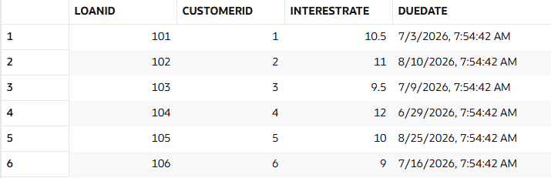
The PL/SQL block:
BEGIN
FOR cust IN (
SELECT CustomerID
FROM Customers
WHERE Age > 60
) LOOP

UPDATE Loans
SET InterestRate = InterestRate - 1
WHERE CustomerID = cust.CustomerID;

END LOOP;
COMMIT;
END;
/
After Update:
SELECT * FROM Loans;
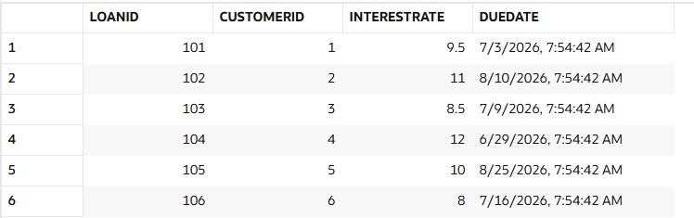
- SOLVING SCENARIO 2:
Scenario 2: A customer can be promoted to VIP status based on their balance.
  - Question: Write a PL/SQL block that iterates through all customers and sets a flag IsVIP to TRUE for those with a balance over $10,000.

Before Update:
SELECT * FROM Customers;

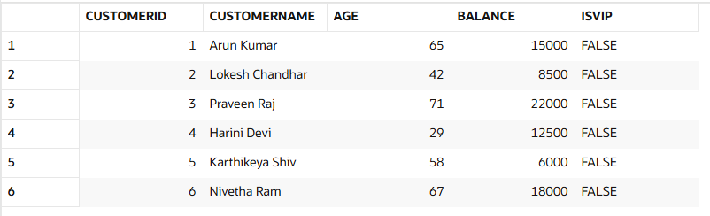

The PL/SQL block:
BEGIN
FOR cust IN (
SELECT CustomerID
FROM Customers
WHERE Balance > 10000
) LOOP

UPDATE Customers
SET IsVip='FALSE'
WHERE CustomerId=cust.CustomerId;

END LOOP;
COMMIT;
END;
/

After Update:
SELECT * FROM Customers;

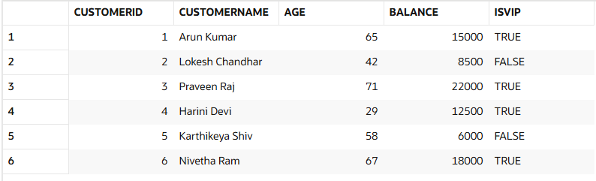

- SOLVING SCENARIO 3:
Scenario 3: The bank wants to send reminders to customers whose loans are due within the next 30 days.
  - Question: Write a PL/SQL block that fetches all loans due in the next 30 days and prints a reminder message for each customer.
The PL/SQL block:
SET SERVEROUTPUT ON;

BEGIN
FOR loan_rec IN (
SELECT c.CustomerName,
l.LoanID,
l.DueDate
FROM Customers c
JOIN Loans l
ON c.CustomerID = l.CustomerID
WHERE l.DueDate BETWEEN SYSDATE AND SYSDATE + 30
) LOOP

DBMS_OUTPUT.PUT_LINE(
'Dear ' || loan_rec.CustomerName ||
', this is a friendly reminder that your loan (ID: ' ||
loan_rec.LoanID ||
') is scheduled for repayment on ' ||
TO_CHAR(loan_rec.DueDate,'DD-MON-YYYY') ||
'. Kindly ensure sufficient funds are available.'
);

END LOOP;
END;
/

